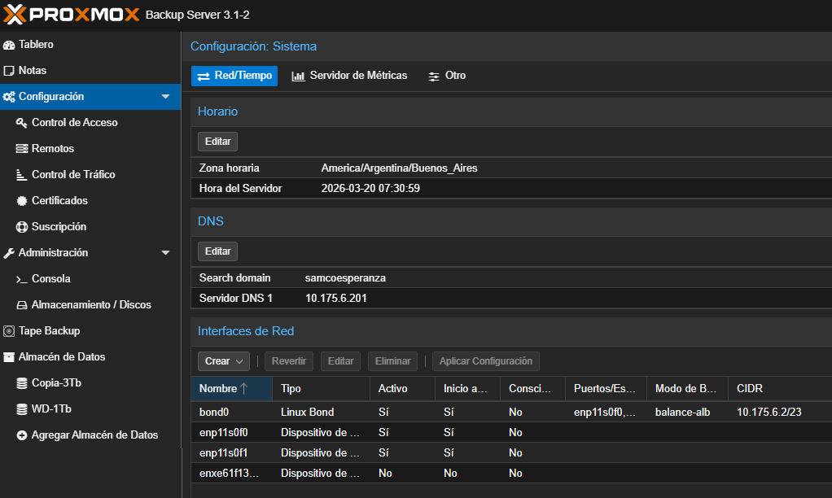

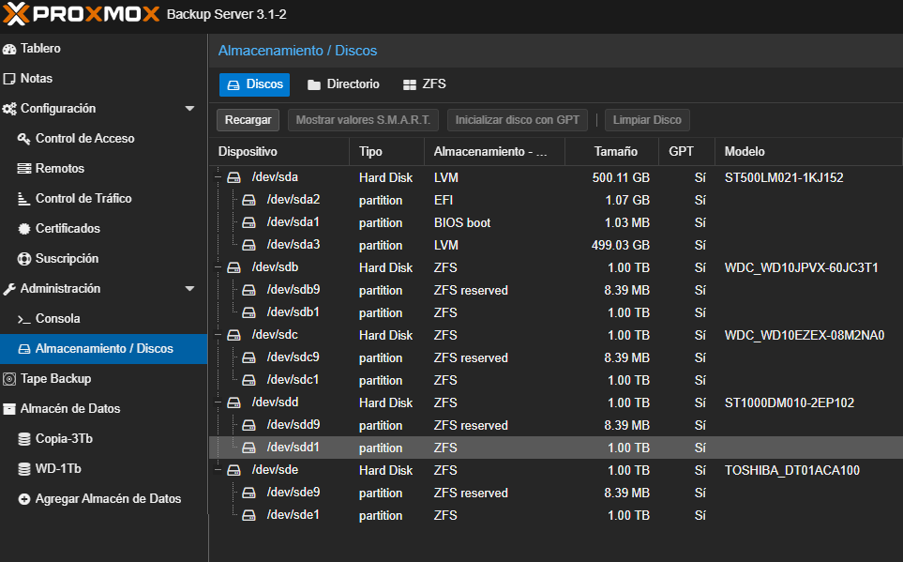

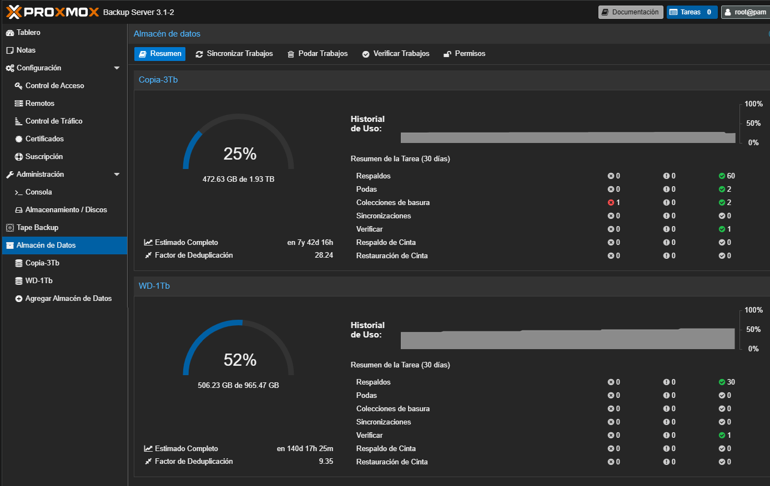

echo "--- MODELO Y DISCOS FISICOS ---" && lsblk -do NAME,SIZE,MODEL,ROTA && \
echo "--- PARTICIONES Y FILSYSTEM ---" && lsblk -f && \
echo "--- ESTADO DE ZFS (Si aplica) ---" && zpool status 2>/dev/null || echo "No usa ZFS" && \
echo "--- ESTADO DE LVM (Si aplica) ---" && vgs && lvs
--- MODELO Y DISCOS FISICOS ---
NAME SIZE MODEL ROTA
sda 465.8G ST500LM021-1KJ152 1
sdb 931.5G WDC WD10JPVX-60JC3T1 1
sdc 931.5G WDC WD10EZEX-08M2NA0 1
sdd 931.5G ST1000DM010-2EP102 1
sde 931.5G TOSHIBA DT01ACA100 1
sr0 1024M TSSTcorpDVD-ROM TS-H353C 1
--- PARTICIONES Y FILSYSTEM ---
NAME FSTYPE FSVER LABEL UUID FSAVAIL FSUSE% MOUNTPOINTS
sda
├─sda1
├─sda2 vfat FAT32 A4EE-49DC
└─sda3 LVM2_member LVM2 001 ZN36qg-B9Qw-4s7a-nsuG-eKCu-b6ws-qkXB98
├─pbs-swap swap 1 70dc0387-7020-4885-94ba-77e829d88179 [SWAP]
└─pbs-root ext4 1.0 0b837e21-f751-43c3-a5f3-2e14b2f248db 407.7G 1% /
sdb
├─sdb1 zfs_member 5000 WD-1Tb 16836529253333183967
└─sdb9
sdc
├─sdc1 zfs_member 5000 Copia-3Tb 18176847826167182566
└─sdc9
sdd
├─sdd1 zfs_member 5000 Copia-3Tb 18176847826167182566
└─sdd9
sde
├─sde1 zfs_member 5000 Copia-3Tb 18176847826167182566
└─sde9
sr0
--- ESTADO DE ZFS (Si aplica) ---
pool: Copia-3Tb
state: ONLINE
scan: scrub repaired 0B in 00:41:37 with 0 errors on Sun Mar 8 01:05:38 2026
config:

NAME STATE READ WRITE CKSUM
Copia-3Tb ONLINE 0 0 0
raidz1-0 ONLINE 0 0 0
wwn-0x50014ee20a0e3c24 ONLINE 0 0 0
wwn-0x5000c500b58913f9 ONLINE 0 0 0
wwn-0x5000039fd5d06cb1 ONLINE 0 0 0

errors: No known data errors

pool: WD-1Tb
state: ONLINE
scan: scrub repaired 0B in 02:14:27 with 0 errors on Sun Mar 8 02:38:39 2026
config:

NAME STATE READ WRITE CKSUM
WD-1Tb ONLINE 0 0 0
wwn-0x50014ee00475490a ONLINE 0 0 0

errors: No known data errors
--- ESTADO DE LVM (Si aplica) ---
File descriptor 20 (/var/log/proxmox-backup/tasks/20/UPID:pbs:0000043E:00001620:00000003:69BD26D2:termproxy::root@pam:) leaked on vgs invocation. Parent PID 593649: -bash
VG #PV #LV #SN Attr VSize VFree
pbs 1 2 0 wz--n- <464.76g 16.00g
File descriptor 20 (/var/log/proxmox-backup/tasks/20/UPID:pbs:0000043E:00001620:00000003:69BD26D2:termproxy::root@pam:) leaked on lvs invocation. Parent PID 593649: -bash
LV VG Attr LSize Pool Origin Data% Meta% Move Log Cpy%Sync Convert
root pbs -wi-ao---- <441.03g
swap pbs -wi-ao---- 7.73g
root@pbs:~#

